# Assignment -4

Python Programming

|  |  |
| --- | --- |
| Assignment Date | 19 September 2022 |
| Student Name | NIRANJAN RAJ M |
| Student Roll Number | 19EC041 |
| Maximum Marks | 2 Marks |

# Question-1:

Consider a list (list = []). You can perform the following commands:

insert i e: Insert integer at position . print: Print the list.

remove e: Delete the first occurrence of integer . append e: Insert integer at the end of the list. sort: Sort the list.

pop: Pop the last element from the list. reverse: Reverse the list.

Initialize your list and read in the value of followed by lines of commands where each command will be of the types listed above. Iterate through each command in order and perform the corresponding operation on your list.

# Solution:

list=[1,3,1,5,2,4,1]

#To insert the element list.insert(5,6)

Print(“The inserted list:”,list) #To remove first occurrence list.remove(1)

Print(“The first occurrence remove list:”,list); #To insert integer at the end

list.append(7)

print(“The appended list:”,list) #To sort the list

list.sort()

print(“The sorted list:”,list)

#To pop the last element list.pop()

print(“The popped list:”,list) #To reverse the list list.reverse()

Print(“The reversed list:”,list)

# Output:

The inserted list: [1,3,1,5,2,6,4,1]

The first occurrence removed list: [3,1,5,2,6,4,1] The appended list: [3,1,5,2,6,4,1,7]

The sorted list:[1,1,2,3,4,5,6,7]

The popped list: [1,1,2,3,4,5,6] The reversed list: [6,5,4,3,2,1,1]

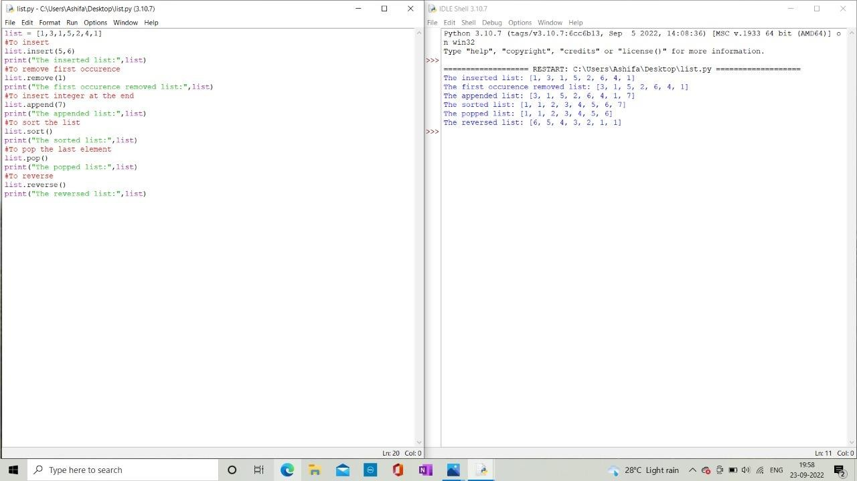

# Question-2:

Write a Calculator program in Python?

# Solution:

# Program make a simple calculator # This function adds two numbers def add(x, y):

return x + y

# This function subtracts two numbers def subtract(x, y):

return x - y

# This function multiplies two numbers def multiply(x, y):

return x * y

# This function divides two numbers def divide(x, y):

return x / y

print("Select operation.") print("1.Add") print("2.Subtract") print("3.Multiply") print("4.Divide")

while True:

# take input from the user

choice = input("Enter choice(1/2/3/4): ") # check if choice is one of the four options if choice in ('1', '2', '3', '4'):

num1 = float(input("Enter first number: ")) num2 = float(input("Enter second number: ")) if choice == '1':

print(num1, "+", num2, "=", add(num1, num2)) elif choice == '2':

print(num1, "-", num2, "=", subtract(num1, num2)) elif choice == '3':

print(num1, "*", num2, "=", multiply(num1, num2)) elif choice == '4':

print(num1, "/", num2, "=", divide(num1, num2)) # check if user wants another calculation

# break the while loop if answer is no

next_calculation = input("Let's do next calculation? (yes/no): ") if next_calculation == "no":

break else:

print("Invalid Input")

# Output:

Select operation.

1. Add 2.Subtract 3.Multiply 4.Divide

Enter choice(1/2/3/4): 1 Enter first number: 2 Enter second number: 2 2.0 + 2.0 = 4.0

Let's do next calculation? (yes/no): yes Enter choice(1/2/3/4): 2

Enter first number: 8 Enter second number: 4 8.0 - 4.0 = 4.0

Let's do next calculation? (yes/no): yes Enter choice(1/2/3/4): 3

Enter first number: 2 Enter second number: 3 2.0 * 3.0 = 6.0

Let's do next calculation? (yes/no): yes Enter choice(1/2/3/4): 4

Enter first number: 8 Enter second number: 2 8.0 / 2.0 = 4.0

Let's do next calculation? (yes/no): n

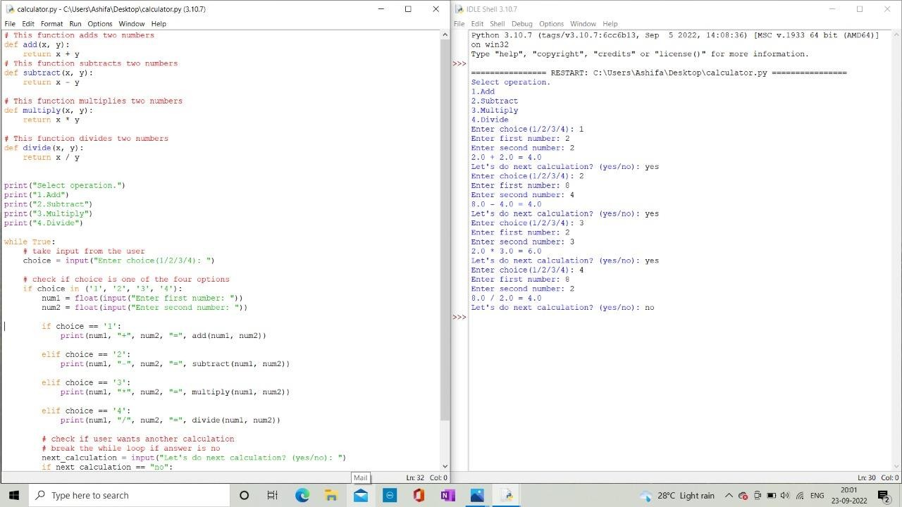

# Question-03:

Write a program to concatenate, reverse and slice a string?

# Solution:

Str1=”Hello”

Str2=”World”

#To concatenate 2 strings Str=” ”.join([str1 ,str2])

Print(“The Concatenated String:”,str) #To reverse a string

Print(“The reversed String:”,str[::-1]) #To sliced a string

Print(“The Sliced String:”,str[6:11])

# Output:

The Concatenated String: Hello World The reversed String: dlroW olleH

The Sliced String: World

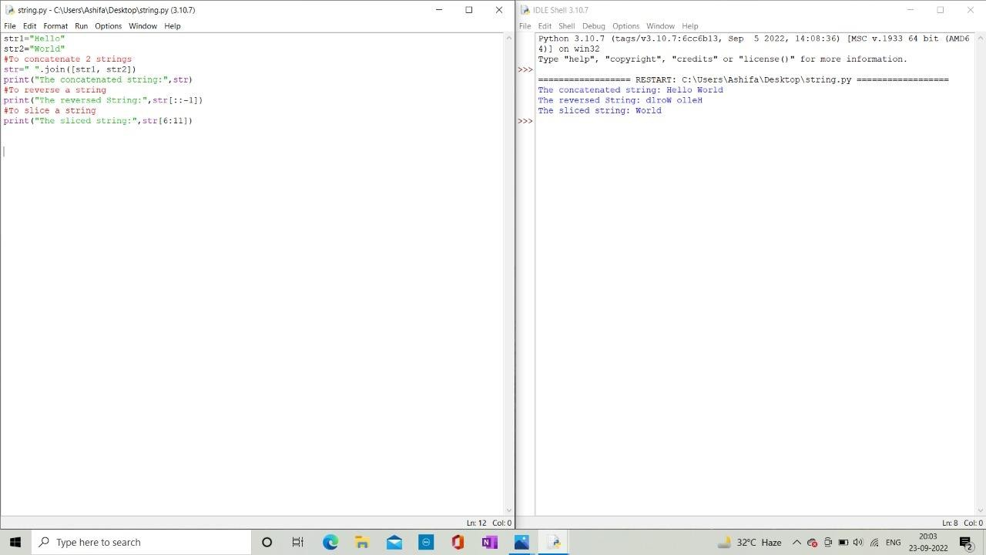

# Question-04:

Why is python a popular programming language?

# Solution:

* The Python language is one of the accessible programming languages available because it has simplified syntax and not complicate, which gives more emphasis on natural language.
* Due to its ease of learning and usage, python codes can be easily written• and execute much faster than other programming language.

# REASONS:

* 1. Python is easy to learn and use,
  2. Python is handy for web development purposes,
  3. The language is extensively used in Data Science,
  4. Has Multiple Libraries and frameworks,
  5. Python can be used in ML Tool,
  6. Python for Academics,
  7. Has a highly supportive community,
  8. Flexibility and Reliability,
  9. Python Automates Tasks,
  10. The first choice always.

# Question-05:

What are the Other Frameworks that can be used with python?

# TYPES OF FRAME WORKS:

1. **Full-stack Framework:**

A full-stack framework, also known as enterprise framework, is the one-stop solution for all development needs. They support the development of databases, frontend interfaces, and backend services.

# Micro Framework:

Micro frameworks are lightweight, minimalistic web application frameworks that have limited functionalities and features. Usually, micro frameworks offer only those components that are required for building an application.

# Asynchronous Framework:

The asynchronous framework is the latest to join the python framework bangwagon. It is a unique micro framework that lets Developers handle and manage large sets of concurrent connections. These frameworks feed on python’s Asyncio library.

# Django:

Django is an open-source, full-stack Python framework. It follows the DRY(Don’t Repeat Yourself)principle. Django allows you to develop any kind of application you desire from large web application to small-scale projects.

# Pyramid:

Another open-source Python framework on our list is pyramid. It runs on Python3 and aims to accomplish as much as possible with minimal complexity. Pyramid boasts of an active community that’s continually contributing to enrich the framework.

# TurboGears:

TurboGears is an open-source, data-drive, full-stack Python framework. It incorporates some of the best components of other python frameworks and comes with many useful libraries.

TurboGears has a user-friendly templating engine and a robust ORM.

# Web2py:

Web2py is a highly scalable, open-source full stack python framework. It comes with its individual web-based IDE that includes a code editor, debugger, and a one-click deployment feature. Web2py is a potent data handling tool.

# CherryPy:

CherryPy is one of the oldest open-source, object-oriented Python micro frameworks.

Following a minimalistic approach, CherryPy is designed for extensibility. It includes mechanisms for hook points and extensions. Moreover, the “Cherry” on top is that any CherryPy-based web application having its unique embedded multi-threaded web server.

# Flask:

Flask is a python micro framework available under the BSD license. It drew inspiration from the Sinatra Ruby framework. Flask requires Jinja2template and Werkzeug WSGI toolkit to run. It has a lightweight and modular design that makes it easily adaptable to a wide range of development needs.

# Sanic:

Sanic is one of the most preferred asynchronous frameworks by developers since it can read and write cookies; allows different types of logging, has plugin support, and supports blueprints for sub-routing within an application, among other things.

# Question-06:

Full Form of WSGI.

# Solution:

* The full form of WSGI is Web Server Gateway Interface.
* A Web Server Gateway Interface (WSGI) server implements the web server•side of the WEGI interface for running python web applications.
* The Web Server Gateway Interface is a simple calling convention for Web servers to forward requests to web applications or frameworks written in the python programming language. The current version of WSGI, version 1.0.1, is specified in Python Enhancement Proposal.